Senator Holly J. Mitchell biography
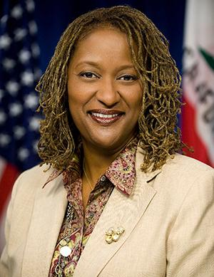
A third-generation native Angeleno, Sen. Holly J. Mitchell is the proud daughter of career public servants and the protégé of community leaders who instilled in her a passion for service. Mitchell, the mother of a 19-year-old son, has devoted her professional life to creating a California where ALL children thrive. She continued her family legacy of leadership when she was named the first African American to chair the powerful Senate Budget and Fiscal Review Committee.

Advocate for values-based budgeting
From 2017 to present Sen. Mitchell has overseen the adoption of three consecutive state budgets with the totaling nearly $215 billion each. As a powerful voice in the Senate, she has been described by The Los Angeles Times as “the Legislature’s moral compass.” She has proved to be just that by directing resources to the most vulnerable populations in our state. The Senator has supported all efforts to expand access to healthcare, early care, and education while reinvesting in neglected services to help the elderly, unhoused and families living in poverty.
Champion for #HealthJustice and #EconomicJustice
This 2018-2019 legislative year’s focus was on health and economic justice with an emphasis on equity and access. Sen. Mitchell authored bills to better the lives of those who need the most assistance. This legislative package was a reflection of her ongoing commitment to address housing discrimination, economic inequity, and bias in access to health services. SB 188, the CROWN Act, gained international media attention, banning discrimination of natural hair by employers and public education institutions. Sen. Mitchell paved the way for others to follow with the CROWN Act being introduced in legislatures across the country.

A compassionate leader
Sen. Mitchell previously lead California’s largest child and family development organization, Crystal Stairs, and worked for the Western Center for Law and Poverty. This experience gave her valuable insights on how to improve services to diverse communities whose needs were not being addressed by state or local governments.
The Senator’s groundbreaking successes include nearly 80 bills signed into law. These bills focus on improving human services, expanding access to healthcare, defending the civil rights of minorities and the undocumented, and reducing the numbers of children growing up in poverty.
In addition to her chairmanship on the Senate Budget and Fiscal Review Committee, she also chairs the Senate Select Committee on Social Determinants of Children’s Well-Being and the Joint Legislative Budget Committee. Sen. Mitchell sits on the Senate Health Committee; the Joint Committee on Rules; the Public Safety Committee; the Labor and Industrial Relations Committee; and the Insurance Committee; Select Committees on Mental Health; the Status of Boys and Men of Color; and Women Work and Families.
Sen. Mitchell has been cited for her outstanding leadership by more than 100 community and business groups, including the Courage Campaign, Sierra Club, United Cerebral Palsy Association, the Greater Los Angeles African American Chamber of Commerce and the Women’s Foundation of California Board. She was named the 2019 National Leader of the Year by the Fathers & Families Coalition of America and this year received the Budget Champion Award from Provider Alliance to End Homelessness.
She currently serves as a legislator in Residence at Mount St. Mary’s University and was appointed to the Los Angeles Coliseum Commission Board.
First elected to the Legislature in 2010, Mitchell represents nearly 1 million residents of the 30th Senate District, which ranges from Century City to South Los Angeles and takes in Culver City, Cheviot Hills, Crenshaw District, USC, downtown L.A. and a portion of Inglewood. For more information, visit Sen. Mitchell’s Web site at www.senate.ca.gov/Mitchell

- Last updated September 2019.

